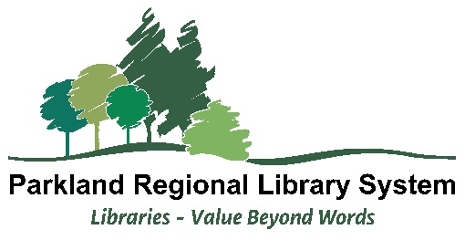

Speaking Notes Template

Advocacy Meetings with MLAs

February 2026

Introduction (30 seconds)
Thank you for meeting with me today. I'm [Name], Chair of the Board at [Library Name]. With me today is [Name], [Board position/library director].

We’re here to share how the library is supporting families, seniors, and employers in your constituency - and why updated provincial funding matters for communities like ours.

Key Message 1: What We Do (1-2 minutes)
Let me share what we're doing in your constituency [pick highlights, create your own}:

- We run early literacy programs that help kids get ready for school. Last year, we had [X number] children participate in story time and reading programs.
- We provide free internet and computer access, which many residents rely on for job applications, schoolwork, business needs, and accessing government services.
- We're a safe, welcoming space where families and seniors can gather without having to spend money.
- We support newcomers to Alberta with settlement resources, English language materials, and connections to community services.
- Through our membership in Marigold Library System, we’re already operating in a highly cost‑effective way - networked computers and technology, collections like eBooks, books, and we can share collections with other libraries across Alberta through interlibrary loan.

These are essential services that your constituents rely on every day to stay connected and supported.

Key Message 2: Funding (2-3 Minutes)
Both Alberta Municipalities and the Rural Municipalities of Alberta have supported a resolution asking for an update to the provincial library operating grant. The reasons are simple:

The provincial operating grant for libraries has remained the same for some time, and population currently used for the per capita amounts are from 2019. At the same time:
- Alberta's population has grown significantly
- Inflation has increased our costs for everything - books, technology, utilities, staff
- We're serving more people with less money

What this means for [Constituency]: Update these to highlight your concerns. Some ideas:
- It’s harder to keep the doors open during the hours people rely on
- Limited capacity to hire or retain staff
- Technology and training needs are growing faster than our budget, including for residents and businesses who need help navigating new tools (including AI models)

Key Message 3: What We Need
We are asking that the provincial per-capita funding be updated to reflect:
- Current population
- The real value of the grant after years of inflation and rising costs, especially in technology

With an updated grant, we could {Update this list with your own ideas, ideally tied to your strategic plan. Here are some ideas}:
- Matina and extend our current opening hours and staffing
- Keep our technology current for residents and local businesses
- Continue delivering strong literacy programs for children, job search support for adults, and other community -focused services and programs

Key Message 4: Supporting Parents and Families (1-2 Minutes) through appropriate and relevant collections
We recognize that parents’ guide their children’s reading choices. Our role is to support them.

We do that by:
Requiring a parent or guardian to sign for every child’s library card.
Providing family account tools so parents can easily see what their children are borrowing.
Training staff to help parents find age‑appropriate materials.
Having clear collection management policies and a transparent process for any concerns about items.
Following policies about unattended children—library staff do not act in place of parents.

Closing (30 seconds)
Libraries offer excellent value for taxpayers. For a modest provincial investment, your constituents get access to services that support education, employment, and community connection.

We hope we can count on your support for updating this grant.

What questions can we answer about how the library serves your constituents?

Preparation Tips:
Before the meeting:
- Consider organizing with neighboring libraries to have a joint meeting with your MLA
- Fill in the speaking notes template with your specific numbers (users served, program attendance, etc.)
- Have 1-2 brief stories ready about real people from the constituency
- Have a copy of your strategic plan to leave behind
- Know your current municipal contribution and how it's changed
- Practice these points out loud - you don't need to memorize, just be comfortable
Note: Note: one of the key speaking points is how public libraries support families and children. This is a deliberate inclusion, as there have been statements made about access to inappropriate content by children in public library environments. This is NOT a call to action. This is an opportunity to discuss, hear any concerns and provide information.

During the meeting:
- Stick to your key messages
- Listen more than you talk
- Thank them for their time

Follow-up:
• Send a thank you email within 24 hours
• Offer to provide additional information if requested
• Invite them to visit the library
• Keep your Board/Library Director or Manager informed

